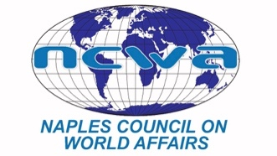
www.NCWA-fl.org

April 13, 2022

FOR IMMEDIATE RELEASE:
Contact:
Carol Green
Communications Chair
carolgreen2@mac.com
(303)886-6531

Sue Soulard is Named NCWA Educator of the Year
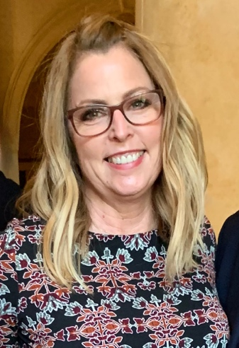
Sue Soulard
Sue Soulard, head of the Social Studies Department and teacher at Gulf Coast High School, has been selected to be the Naples Council of World Affairs (NCWA) 2022 Educator of the Year.
Sue has made a wide variety of continuing contributions for 20 years to student programs sponsored by NCWA. She has been a teacher in Collier County Public Schools and Model UN coach since 2002 and has been head of the Social Studies Department since August 2015.
Her teams came in first and second in this year’s NCWA Academic World Quest. She will be taking the first-place team to Washington DC to compete in the national competition.
For the 2022 Model UN competition held at Florida Gulf Coast University, the Gulf Coast High School teams excelled and won $27,000.
She set up a Shark Model UN competition with local schools, run entirely by her students, in which students pitch the positions of countries for which they are mock delegates to a panel of judges.
Students from Gulf Coast High School have received scholarships from the NCWA for international relations experiences this summer in South Korea, a Tufts program in Geneva, a program at Oxford, and a Georgetown University summer program.
Her Gulf Coast High School teams also have won several NCWA High School Academic World Quest competitions over the years.
Sue has instilled in Gulf Coast students a quest for international relations knowledge and at the same time has raised their critical thinking skills to a high level, said Mark Walchak, chair of NCWA’s School Outreach Program.
In addition to working with NCWA programs, Sue has coached the Debate Team since 2013 and has sponsored the National Honor Society at the school since 2018. She was named 2011 Macy’s Florida Teacher of the Year for Collier County, an award sponsored by Macy’s and the Florida Department of Education to a teacher from each county in Florida who demonstrates a “superior ability to foster excellence in education and contribute to the continuous improvement of student learning and the school environment.”
###

