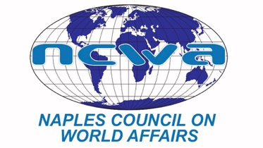
www.ncwa-florg

March 9, 2022

FOR IMMEDIATE RELEASE:

Humanitarian aid is one of the best foreign policies that we have, former Ambassador Tony P. Hill told high school students who participated in the Southwest Florida Model United Nations Conference. The largest humanitarian organization in the world feeds about 150 million people, with the U.S. contributing about 40 percent to the effort. And yet, 24,000 people die each day from hunger, so there is more work to do
Hill was appointed U.S ambassador to the UN Agencies for Food and Agriculture by President George W. Bush and served as chief of the U.S Mission to the UN Agencies in Rome – the World Food Programme, the Food and Agriculture Organization and the International Fund for Agricultural Development. He was nominated for the Nobel Peace Prize three times for his humanitarian and hunger-related work.
A billion people make a dollar a day, and in our own country, millions are food insecure, Hall said. From the beginning of his passion for humanitarian work after learning about hunger in Ethiopia, Hall described his evolution, including a 22-day fast while he was a Congressman after his committee was dissolved. Publicity generated by his fast brought national recognition and support for his efforts.
He invited the students to take up a life of service.
“We have to educate America,” he said. “We need for you to think about running for office.”
He recalled a lesson learned from Mother Teresa during a visit to India: “Do the thing that’s in front of you. Look around.
“Use your life for something that matters,” he said. The local Model UN conference is sponsored by the Naples Council on World Affairs in partnership with FGCU’s political science department.
###

Contact: Alan Van Egmond
alanvanegmond@gmail.com
Cell: (301) 674-1615

