FOR IMMEDIATE RELEASE

Contact: Martha L Williams, NCWA Board Member and AWQ Communications: Mwilliams@wnmn.org
847.778.9806

Please see pictures of first, second and third place winners below.

NCWA crowns Aubrey Rogers High School winner of 2024 High School Academic WorldQuest; headed to national competition in Washington, D.C.

NAPLES, FL. – March 24, 2024 – Newly minted high school, Aubrey Rogers H.S. in Naples, won Saturday’s Academic WorldQuest’s competition at the Community School in Naples. For the first time, a group of four freshmen earned the champion’s title.

The winning team included Aaron Bozman, Bennett Bozman, Luke Brown and Alex Ewy. They were among 84 students and 21 teams from six high schools in Collier County. The Bozmans and Brown served on the team that won the AWQ middle school championship in 2023. The competition is a program of the Naples Council on World Affairs (NCWA).

“I’m very proud of them. It’s phenomenal for the inaugural year of Aubrey Rogers High School. It’s a brand new school, and they are all freshmen. I’m excited for the future,” said Meghan Joyce, Aubrey Rogers High School’s’s department chair for social studies and AWQ coach. “They are some of the smartest kids I’ve ever met.”

For more than a decade, NCWA has hosted Academic WorldQuest competitions for middle schools and high schools in Southwest Florida. The ARHS team will compete in the national AWQ April 19-20 in Washington, D.C., benefitting from a grant funded by World Affairs Councils of America.

AWQ inspires high school students and teachers across the United States to embrace a culture of global engagement. Nationwide, more than 40 local World Affairs Councils host community Academic WorldQuest competitions throughout the year, engaging more than 3,000 students in schools across diverse geographic and economic lines.
Second and third places went to Gulf Coast High School’s teams, including Emiliana Aguilera, Isabella Lala, Selma Parfene and Everett Tedrow in second place; and Quinn Fairbrother, Khang Lee, Katie Saadeh and Aiden Stien in third place. NCWA bestowed medals and Amazon gift cards to the winners.

NCWA’s middle school AWQ took place at the Community School on March 2. The results were: Community School of Naples, first place; Pine Ridge Middle School, second place; Community School of Naples, third place.

“NCWA places a premium on providing opportunities for young people to obtain the exposure to global affairs that will encourage them to pursue careers in international relations or international business.” said Jim Seymour, manager of NCWA’s AWQ competitions. “None of this would be possible if it were not for the dedication, hard work and passion of the teachers who have coached their teams in preparation for this competition.”
This season's subject categories for the high school competition were:
- The North Atlantic Treaty Organization (NATO): Alliance and Collective Defense in a Changing World
- Demographic Dividends - Population Shift in Africa
- The Global South
- Sports and Diplomacy
- Country in Focus: South Korea
- Promoting a Green Europe
- Women's Contributions to Track II Diplomacy
- Navigating AI: The Global Workforce
- Great Decisions
- Current events
Collier County high schools participating were Aubrey Rogers High School, Community School of Naples, Gulf Coast High School, Lely High School, Lorenzo Walker Technical High School and Naples High School.

The High School Academic WorldQuest Teams were:
Aubrey Rogers High School’s coach is Meghan Joyce.
Team A: Adrian Alvarez-Garcia, Arlind Agollari, Bianca Kisic, Abigail Peterson
Team B: Luke Brown, Alex Ewy, Bennett Bozman, Aaron Bozman
Team C: Topher Fontana, TJ Zelek, Ryan Peachey
Team D: Sophia Hajjar, Marianna Franco, Samantha Mey, Alexa Allers
Team E: Kieran Marks, Zach Goetz, Jack Pustizzi

Lely High School’s coach is Aaron Chambers.

Team A: Sophia Friedhoff, Julian Junkroski, Juliana Noreus, Celina Alber

Community School of Naples’ coach is Susan Hertig.
TEAM A: Noah Mansson, Cameron Brenner, Nick Street, Suran Roa
TEAM B: Gabe Miller, Will Gavin, Brooke Glick, Grace Cunnigham
TEAM C: Sophia Yurko, George Barbounis, Mimi Goldberg, Anthony Avola
TEAM D: Devon Poirier, Darius Zafar, Johnny Brugger, Shimon Levy

Gulf Coast High School’s coach is Sue Soulard.
Team A: Adam Dorio, Naresh Ram, Nathan Rubin, Dylan Slye
Team B: Selma Parfene, Isabella Lala, Everett Tedrow, Emiliana Aguilera
Team C: Khang Lee, Quinn Fairbrother, Aiden Stien, Katie Saadeh
Team D: Rita Saadeh, Micah Lynn, Braxton Cabrera
Team E: Scott Jarman, David Sage, Vincent Ngyuen, Soham Dihenia
Team F: Archee Dobas, Emma Dorey, Erin Hannah, Isaac Garatejo Zambrano

Lorenzo Walker Technical High School’s coach is Rob Alvarez.

Team A : Estephania Careaga, Kelsey Chimilio, Diego Reyes Martinez, Ilormise Sirenord
Team B: Sutton Crouch, Julie Remy,Maralyn Amador, Selvin Perdomo

Naples High School’s coach is Kelly Romero-Bettridge.

Team A: Albar Setiawan, Marlon Garcia, Sebastian Flores-Choy, Ramy Khadraoui
Team B: Victoria Ujlaky, Diana Arredondo-Salazar, Julian Capriari, Angel Gabriel-Delgado
Team C: Monica Tran, Joshua Jinkins, Talissa Mardigras, Anthony Pinto

For more information about NCWA’s Academic WorldQuest, go to:
https://www.ncwa-fl.org/academicworldquest.html

For more information about AWQ, contact:
NCWA Board member and AWQ Communications
Martha L Williams
847.778.9806
mwilliams@wnmn.org

NCWA’s Mission
NCWA is a non-profit, non-partisan membership organization whose mission is to educate, inspire and engage our community in international affairs and critical global issues.
About NCWA

Over the last 40 years, NCWA has been providing Southwest Florida’s globally curious with a complete international affairs experience. NCWA has 1,700+ members from Collier and Lee counties and is a member of the World Affairs Council of America, which has 93 chapters in 40 states and 90,000+ members.

Naples Council on World Affairs
https://www.ncwa-fl.org/

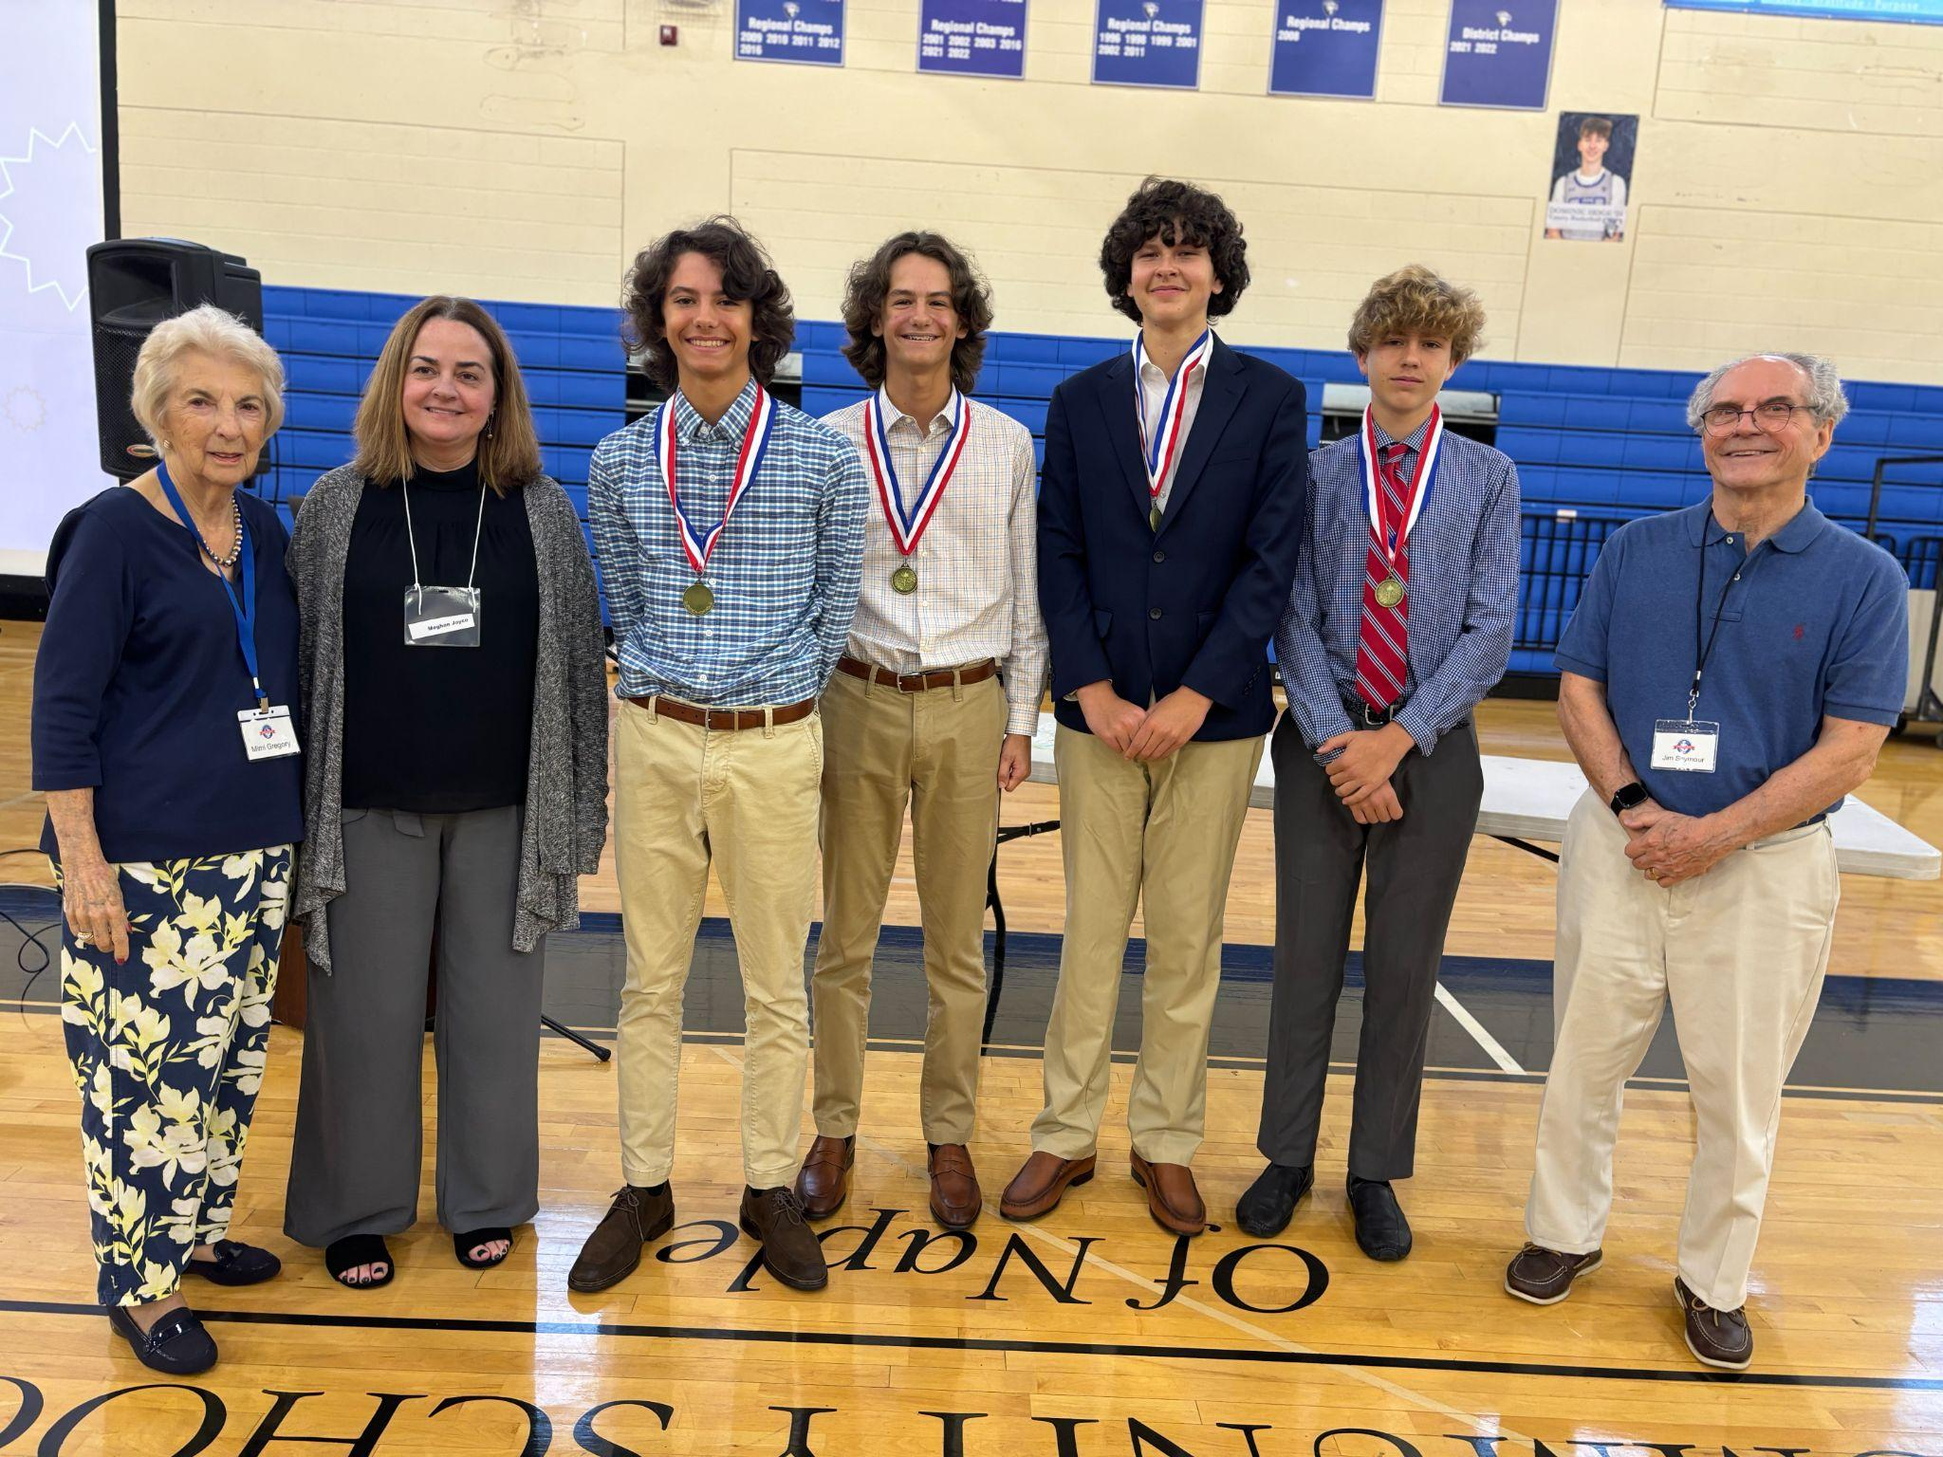
(L-R) Mimi Gregory, NCWA board member; Meghan Joyce, Aubrey Rogers’ AWQ coach; students Aaron Bozman, Bennett Bozman, Luke Brown and Alex Ewy. Jim Seymour, manager of NCWA’s high school AWQ competition.

.

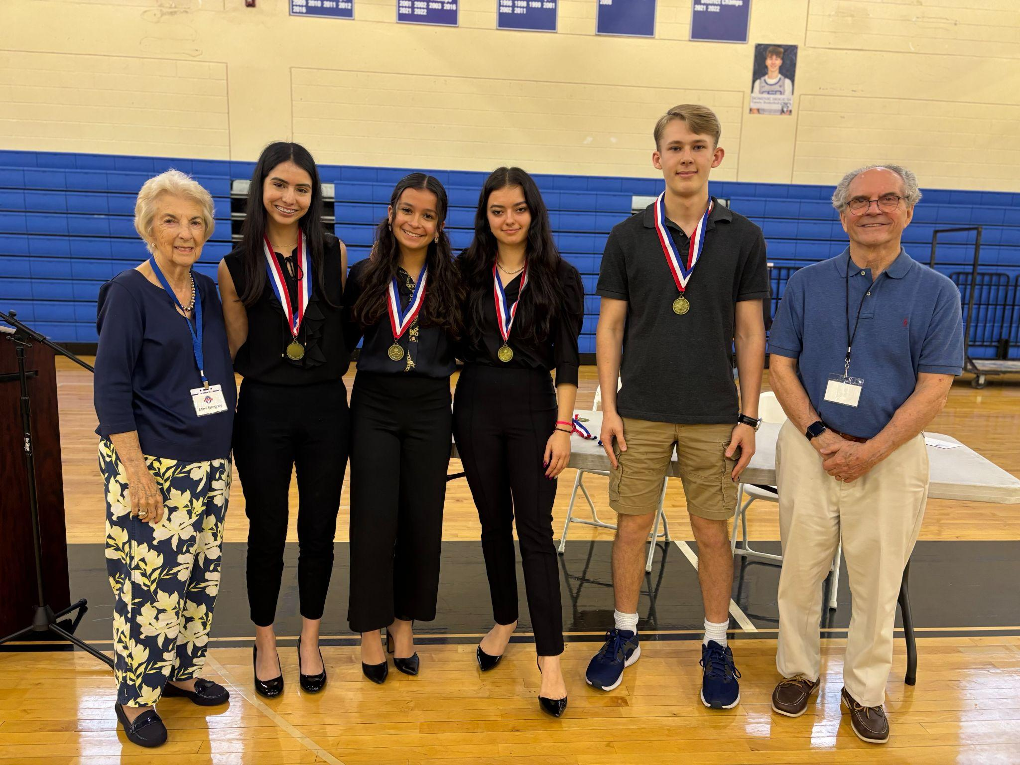
(L-R) Mimi Gregory, NCWA board member; Second place winners from Gulf Coast High School include: Emiliana Aguilera, Isabella Lala, Selma Parfene, Everett Tedrow. Jim Seymour, Jim Seymour, manager of NCWA’s high school AWQ competition; (missing) Sue Soulard, Gulf Coast High School coach.

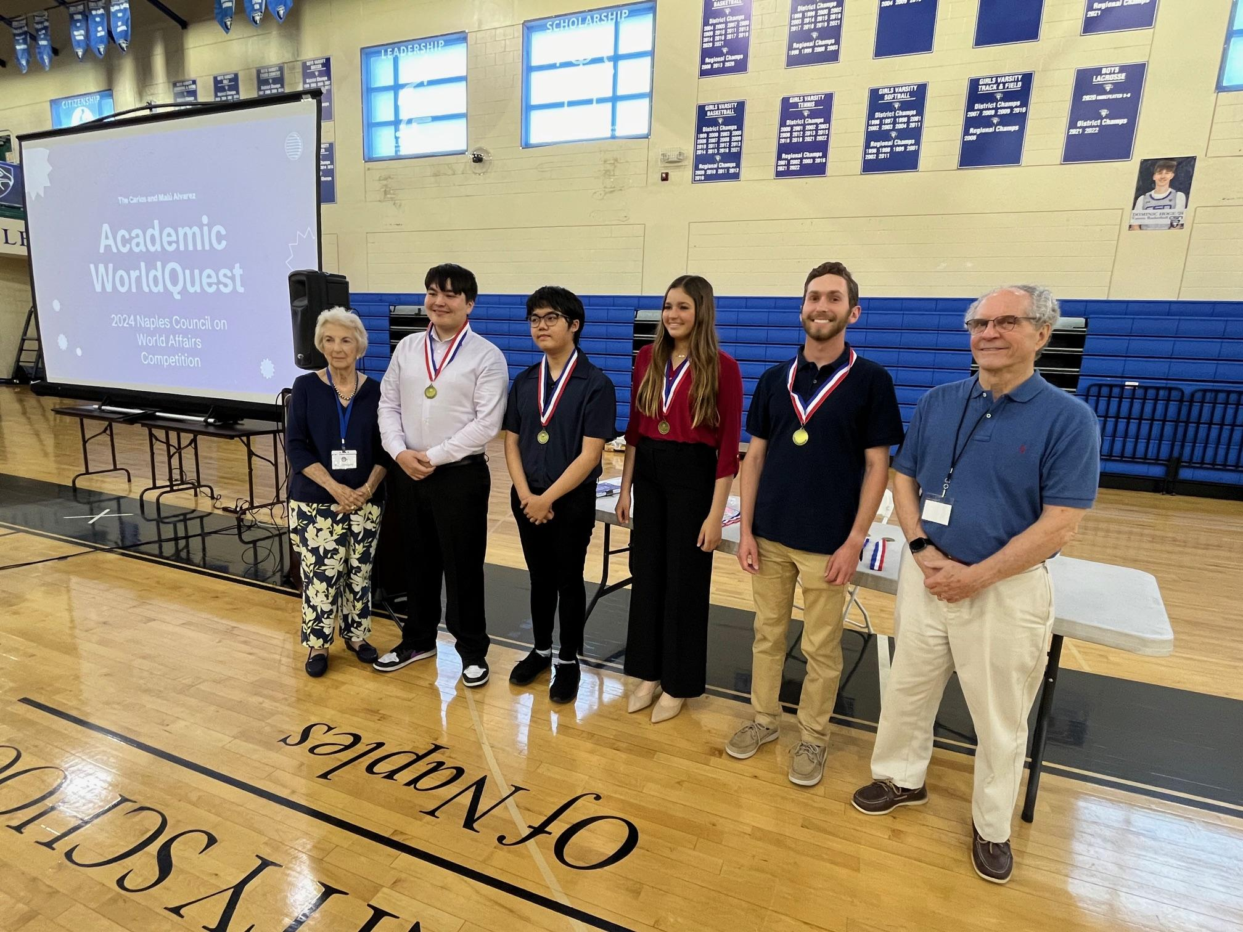

(L-R) Mimi Gregory, NCWA board member; Third place winners from Gulf Coast High School include: Quinn Fairbrother, Khang Lee, Katie Saadeh, Aiden Stien, Jim Seymour, manager of NCWA’s high school AWQ competition; (missing) Sue Soulard, Gulf Coast High School AWQ coach.

